**Web App for Micro:bit**

**WorkSheet 3**

**Ahmed Samaau**

**S2102122**

This project is for the first option given in the worksheet, which is a simple web app/server that talks to the microbit to display some form of sensor data, button presses, a visualization of the LED screen, and so on.

I have built a React App which will connect to the Micro:bit using Node.js and typescript.

Before the program can be run Node.js should be installed on the system.

After installing Node.js, I created a project called ‘jacdac-react-simple’ and installed the relevant dependencies.

This folder is opened in VSCode and the App.tsx is edited, and two new TypeScript files are created called Connection.tsx and Service.tsx to make maintaining the code easier.

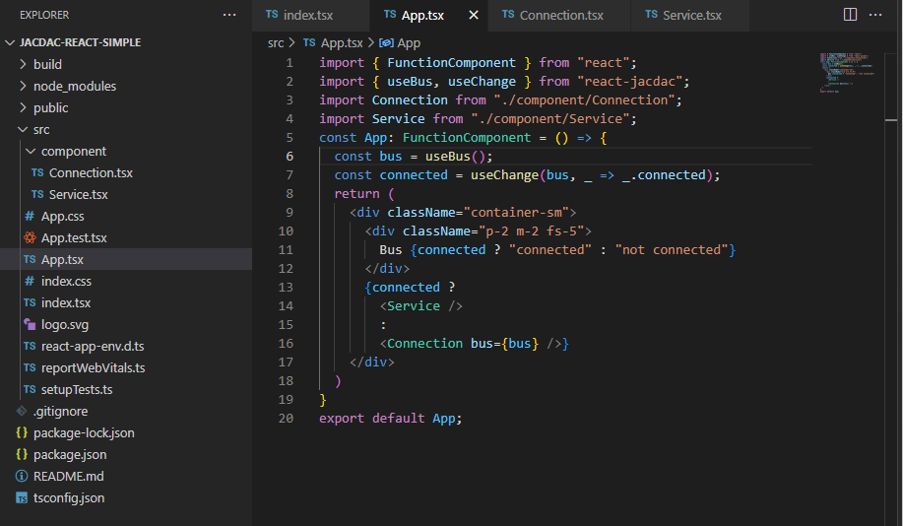

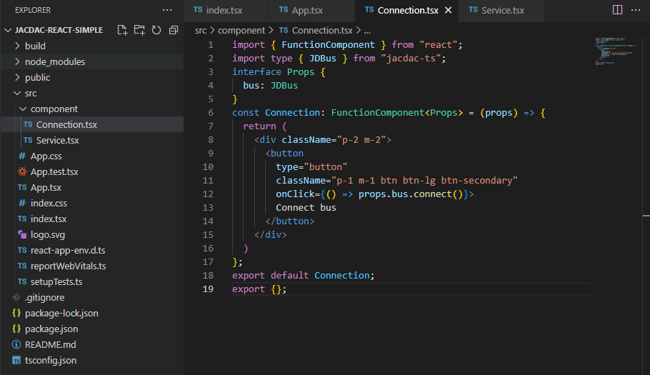

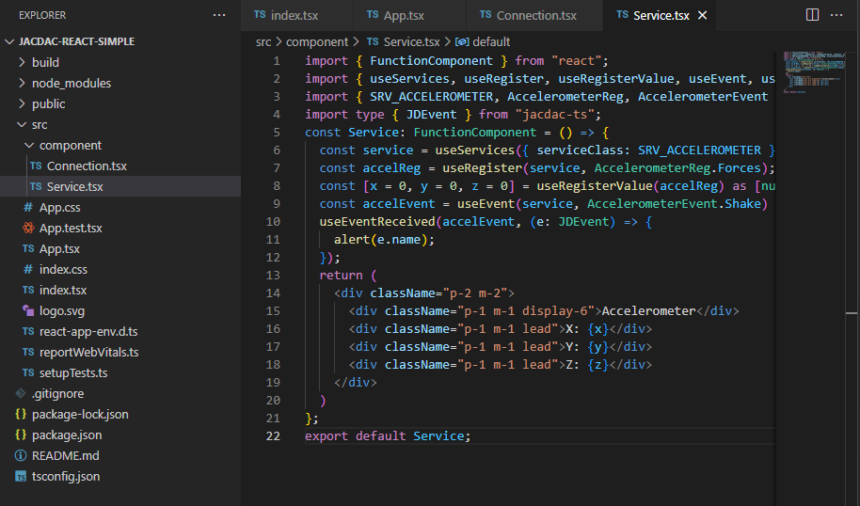

Now using the Command Prompt, change into the ‘jacdac-react-simple’ directory and type the command

npm start

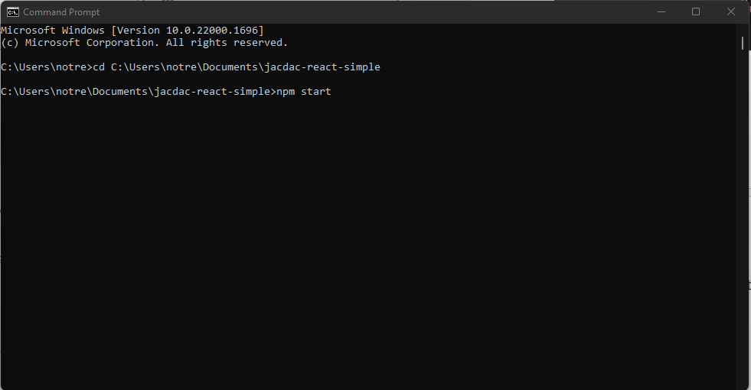

You will see this output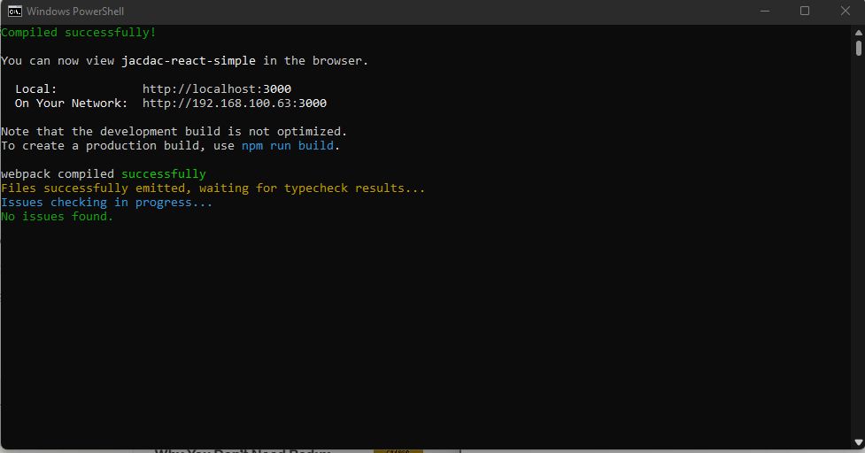

and a page called React App will open up in your browser

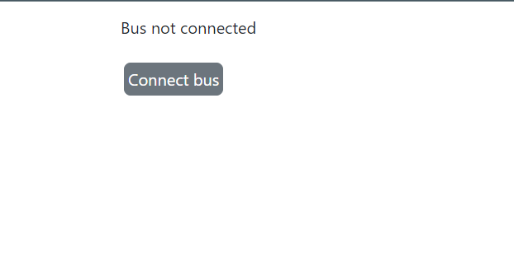

Now connect the Micro:bit using a cable and press the ‘Connect Bus’ button and select your Micro:bit from the menu and it will be connected.